**Deploying a Restaurant Application to Cloud**

**Course-end Project 3**

1. Create a website for the restaurant.

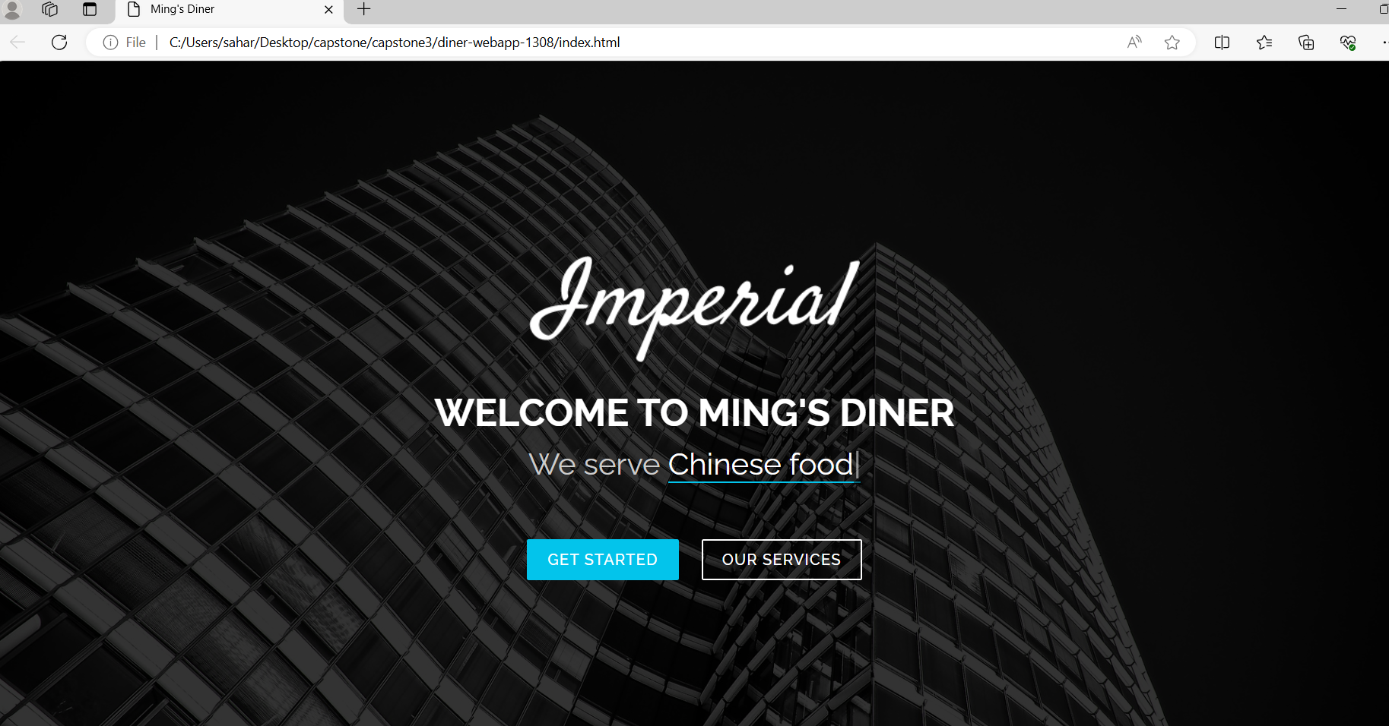

1. Create a S3 static website bucket.

* 1. Upload the website :

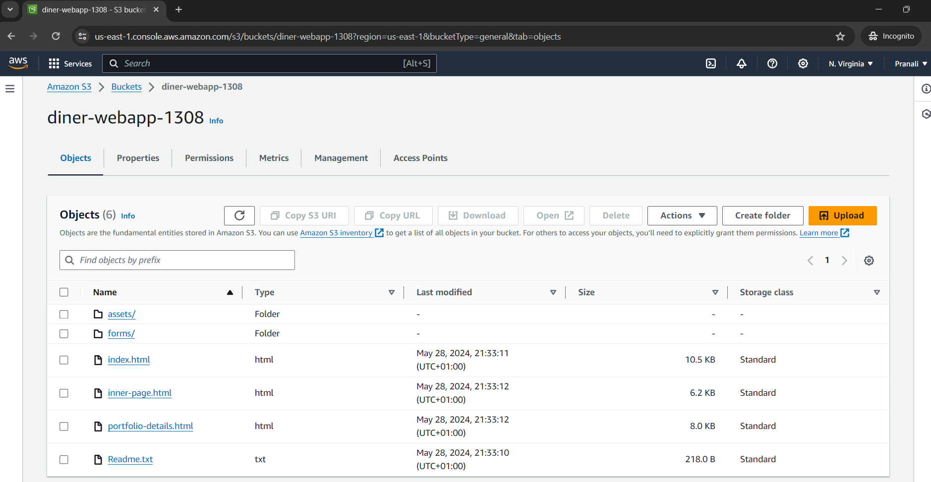

* 1. Create the bucket policy:

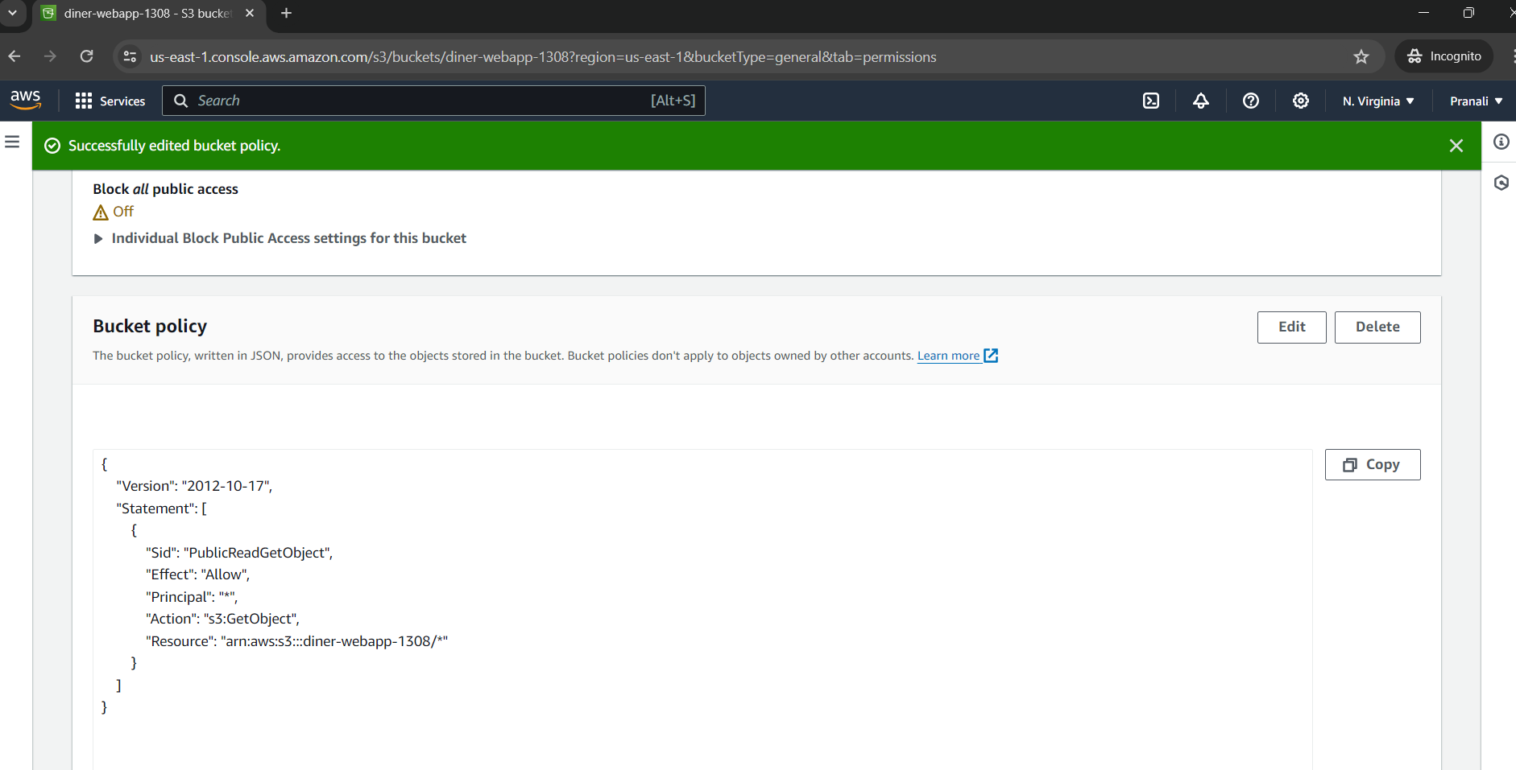

AWS S3 Endpoint: <https://diner-webapp-1308.s3.amazonaws.com/index.html>

1. Create CloudFront Distribution:

* 1. Metrics:

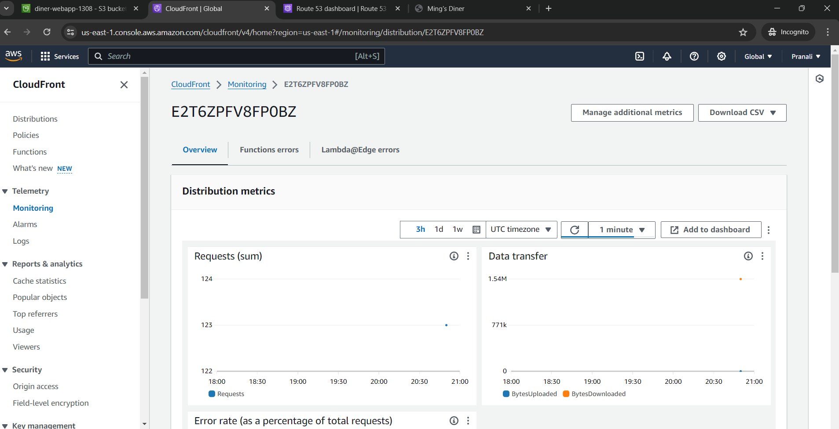

4.1 Deploy Routing Policy by Route53 Creation.

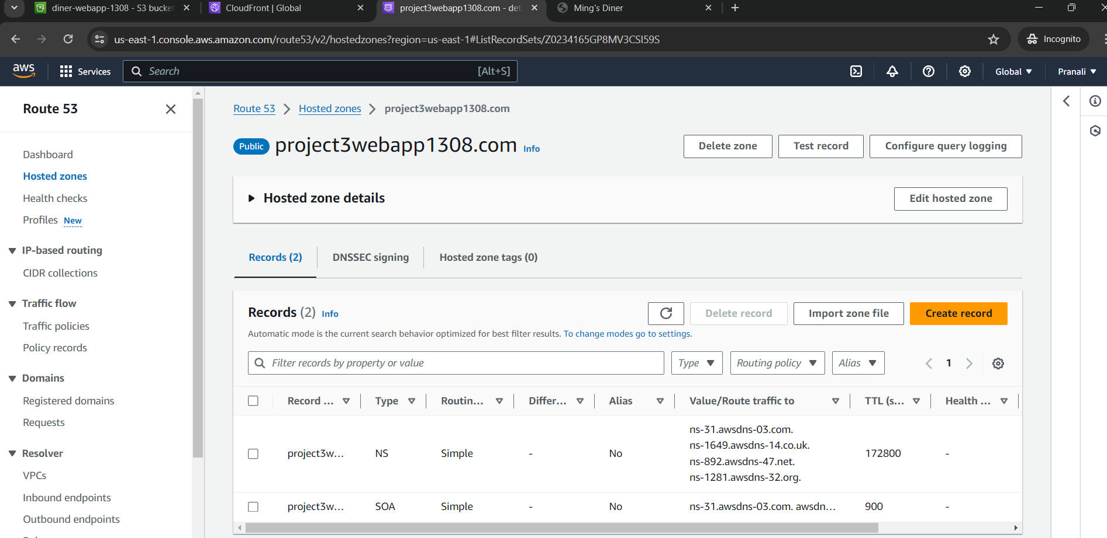

4.2 Create Records:

